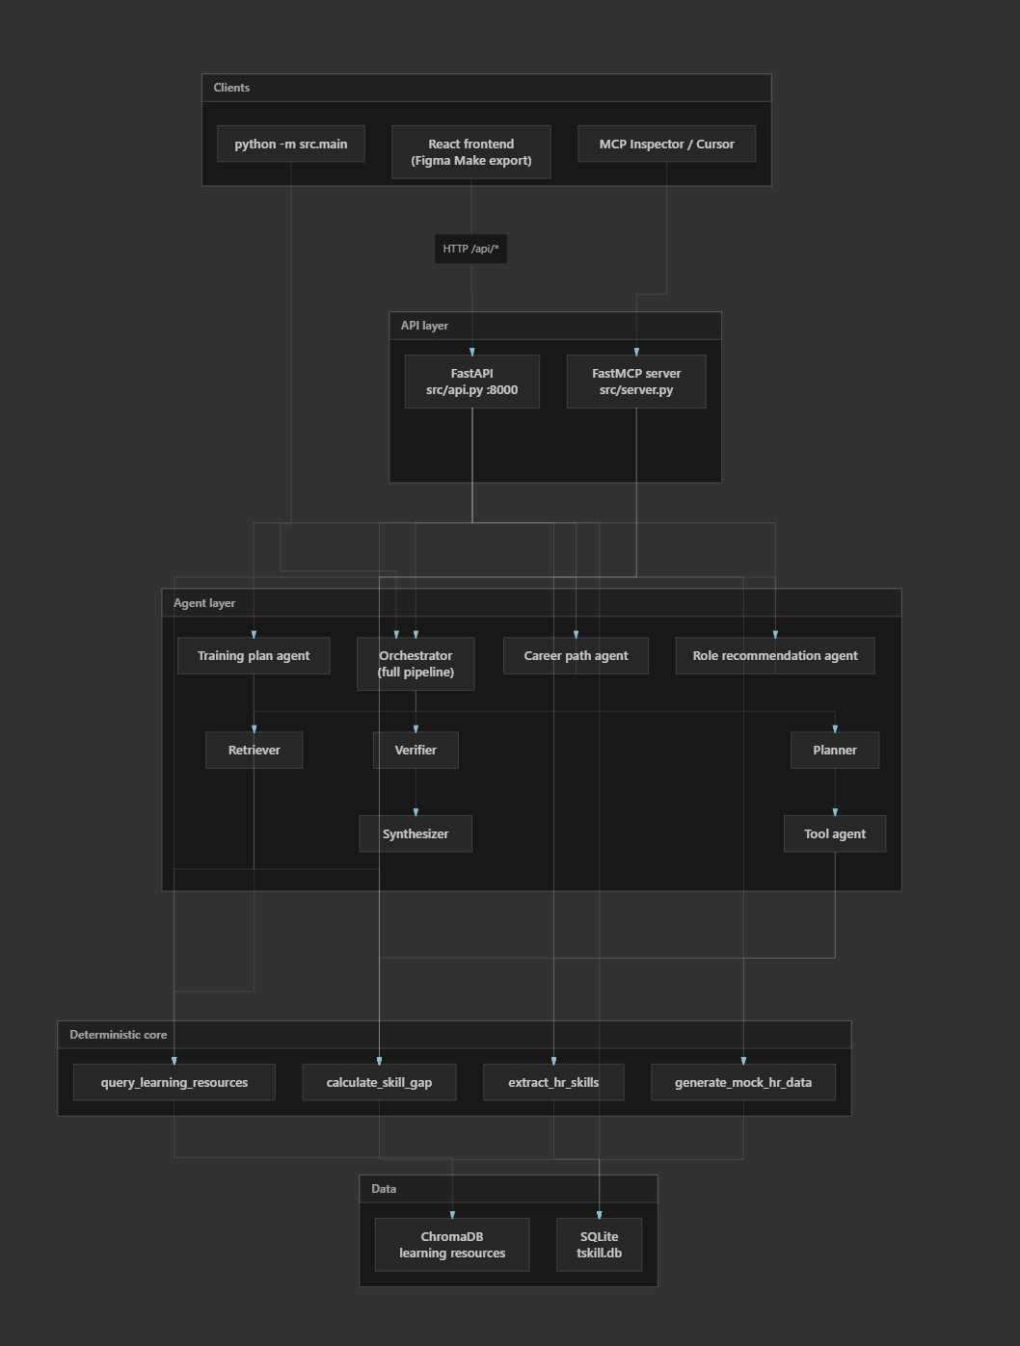

Figma Make → design export → React frontend (UI)
↓ REST /api
FastAPI (transport)
↓ direct imports
┌─────────────────┴─────────────────┐
│ src/tools/ (core logic) │
│ calculate_skill_gap, extract_hr, … │
└─────────────────┬─────────────────┘
↑ also exposed as
FastMCP (MCP tools)
↑ used by
Orchestrator + feature agents (OpenAI)
↑ used by
CLI /api/evaluate / tabs

Flow:
- Planner (OpenAI) — breaks the request into steps
- Tool agent — runs HR extract, mock data, skill gap (deterministic)
- Retriever — queries ChromaDB for training resources
- Verifier — checks gap math and T/N/M shape logic
- Synthesizer (OpenAI) — produces a markdown development plan
This is classic agentic RAG: plan → tools + retrieval → verify → synthesize.
B. Feature-specific agents (what the UI mostly uses)
The tabbed UI mostly bypasses the full orchestrator and calls specialized pipelines:
- Training plan — calculate_skill_gap → group by category → ChromaDB retrieval → OpenAI markdown plan
- Career path — gap analysis + deterministic trajectory → OpenAI career narrative
- Role recommendations — fit scoring + OpenAI rationale
Gap analysis itself is pure Python — no LLM — so rankings can't be hallucinated:
skill_gap = 2×(value_to_sponsor − rating) + (value_to_mitre − rating)
T/N/M shape still uses skill_rating × value_to_sponsor product scores.

5. Data layer
Store | Purpose
SQLite (data/tskill.db) | Skill taxonomy (7 pillars), employee profiles, ratings, open roles
ChromaDB | Embeddings for internal/external learning resources
HR data can be real (SQLite) or synthetic (generate_mock_hr_data via OpenAI).

6. How the pieces relate (mental model)
Figma Make → design export → React frontend (UI)
↓ REST /api
FastAPI (transport)
↓ direct imports
┌─────────────────┴─────────────────┐
│ src/tools/ (core logic) │
│ calculate_skill_gap, extract_hr, … │
└─────────────────┬─────────────────┘
↑ also exposed as
FastMCP (MCP tools)
↑ used by
Orchestrator + feature agents (OpenAI)
↑ used by
CLI /api/evaluate / tabs

7. What’s essential vs. optional
Layer | Essential for the UI? | Role
React frontend | Yes | User-facing tabs, sliders, charts
FastAPI | Yes | REST bridge to Python
src/tools/* | Yes | Deterministic gap math, HR, retrieval
SQLite + ChromaDB | Yes | Profiles, taxonomy, learning resources
Feature agents | Partial | Needed for AI training/career/roles tabs
Full orchestrator | Optional | CLI and /api/evaluate only
FastMCP server | Optional | MCP Inspector / Cursor integration, not the web app

Summary
- Figma supplied the UI design via Make export; the live app is a standard React SPA.
- FastAPI is what the frontend actually uses.
- MCP is a second interface to the same tools, mainly for dev/agent tooling.
- Multi-agent shows up in two ways: the full Planner→Tool→Retriever→Verifier→Synthesizer pipeline, and smaller LLM agents per tab.
- Deterministic tools (especially calculate_skill_gap) sit at the center so math and rankings stay trustworthy while LLMs handle narrative plans.

